

**Doctor Patient Management System**

**Software Requirement Specification (SRS) Document**

**Sprint Implementation**

**Project Timeline: 20.10.2022 - 27.10.2022**

**INDEX**

1. Introduction
   1. Purpose --------------------------------------------------- 3
   2. Intended audience --------------------------------------------------- 3
   3. Intended use --------------------------------------------------- 3
   4. Scope --------------------------------------------------- 3
2. Overall description --------------------------------------------------- 4
   1. Assumptions and dependency --------------------------------------------------- 4
3. System feature and requirements --------------------------------------------------- 4
   1. Functionality --------------------------------------------------- 4
      1. Doctor_Registration --------------------------------------------------- 4
      2. Doctor_Slot_Selection --------------------------------------------------- 4
      3. Patient_Registration --------------------------------------------------- 4
      4. Book_Appointment --------------------------------------------------- 4
      5. View_Bookings --------------------------------------------------- 4
      6. Record_Patient_History --------------------------------------------------- 4
      7. View_Patient_History --------------------------------------------------- 4
      8. Doctor_File_Maintenance --------------------------------------------------- 4
      9. Edit_Doctor_Info --------------------------------------------------- 4
      10. Patient_File_Maintenance --------------------------------------------------- 4
      11. Doctor_License_Query --------------------------------------------------- 5

3.2 System requirement --------------------------------------------------- 5

3.2.1 Tools to be used --------------------------------------------------- 5

3.3 System feature --------------------------------------------------- 5

4. Data Flow Diagram

4.1 DFD level 0 ---------------------------------------------------- 6

4.2 DFD level 1 ---------------------------------------------------- 7

1. **Introduction**

The introduction of the software requirement specification provides an overview of the entire software. The entire SRS with overview description purpose, scope, tools used and basic description. The aim of this document is to gather, analyze and give an in-depth insight into the complete Doctor Patient Management System by defining the problem statement in detail. The detailed requirements of Doctor Patient Management System application is provided in this document.

* 1. **Purpose**: **-**The purpose of this document is to describe the requirements for the Doctor Patient Management System. The main purpose of the Doctor Patient Management System is to manage the doctor and patient data.
  2. **Intended Audience: -**This document is intended to be read by, Client.

* 1. **Intended Use: -**
* Development Team
* Maintenance Team
* Clients

Since this a general-Purpose Software Thus any one Can access it.

* 1. **Scope: -**This project aims to create and develop the doctor Patient Management System which takes patients Aadhar number and personal details for registration and login. It allows the user to add the personal data and choose the operation to do, for doctor to provide the slots for an appointment. Similarly for patient, to book the appointment with the doctor. All the information about a particular user is stored in a retrievable manner.

**2. Overall Description: -**

It is a Doctor Patient Management System used to keep the track of all the appointments booked and details of the patient. This consists of the database which will store the information of the patient and doctor. It will give all the information of the appointment made by the patient by selecting the desired preference like slot and specialization of doctor. The doctor can change the slot preference, view the appointments and details of the patient. Doctor can also view the previous appointment history of the patient with him. All the patient and doctor details can be accessed and modified by the admin.

* 1. **Assumptions and Dependency: -**
* System should have Ubuntu Linux installed.
* System should have either 4GB or more RAM.
* The service is used preferably on a desktop or laptop.

**3. System Features and Requirement :-**

* 1. **Functionality :-**
     1. **DPMS_01 :** Doctor_Registeration : All the details of doctor will be registered and duplicate data will be checked.
     2. **DPMS_02 :** Doctor_Slot_Selection : It will choose the slot which doctor want to give for allotment to the patients.
     3. **DPMS_03 :** Patient_Registration : All the details of patient will be registered and the duplicate data will be checked.
     4. **DPMS_04 :** Book_Appointment : It contains the list of Specialization and slot for the patient to book appointment.
     5. **DPMS_05 :** View_Bookings : The doctor can view his appointment and other details when booked by the patients. The patient can see his booked appointments with doctor like doctor name, MCI License number etc.
     6. **DPMS_06 :** Record_Patient_History : It will record thee patient details including treatment, diseases, medication etc to doctor.
     7. **DPMS_07 :** View_Patient_History : It will display the history of patient with details like name, treatment, medications, etc to doctor.
     8. **DPMS_08 :** Doctor_File_Maintenance: The admin can add, delete, view and modify doctor details with this function.
     9. **DPMS_09 :** Edit_Doctor_Info :It will allow doctor to edit details like Mobile no., address, slot, e-mail.
     10. **DPMS_10 :** Patient_File_maintenance**:** The admin can add, delete, view and modify patient details with this function.
     11. **DPMS_11 :**Doctor_License_Query: Admin can view any doctors appointment list with doctors MCI license.

**3.2 System Requirement :-**

**3.2.1. Tools to be used :-**

* C Language
* File Handling
* Valgrind
* Splint

**3.3 System Features**

* Supportability: The system is easy to use.
* Design Constraints: The system is built using only C language.
* Usability: The Doctor Patient Management System is used to replace the old system for taking appointment where person have to visit the doctor’s clinic first for registering himself. By using this Management system patient can pre book the appointment with the doctor according to the desired need.
* Reliability & Availability: The system is available 24/7 that is whenever the user would like to use the system, they can use it up to its functionalities.
* Performance: The system will work on the user’s terminal.

1. **Data Flow Diagram:-**
   1. **Level 0 DFD:-**

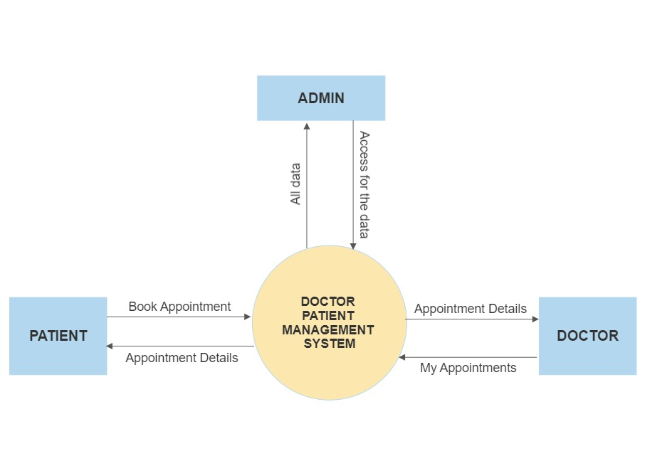

* 1. **Level 1 DFD:-**

